**Test Report**

1. **Introduction**

* What is Chrome Extension?

Google Chrome extensions are essentially programs you can add to your Chrome browser to alter its functionality. These tools are designed to automate tasks within your browser, tweak existing features, and enhance convenience. It is built using HTML, JavaScript, and CSS scripts, Chrome extensions resemble miniature websites uploaded to the Chrome store. However, what sets them apart is the inclusion of a manifest file, which assigns extra functionality to the websites.

* Purpose

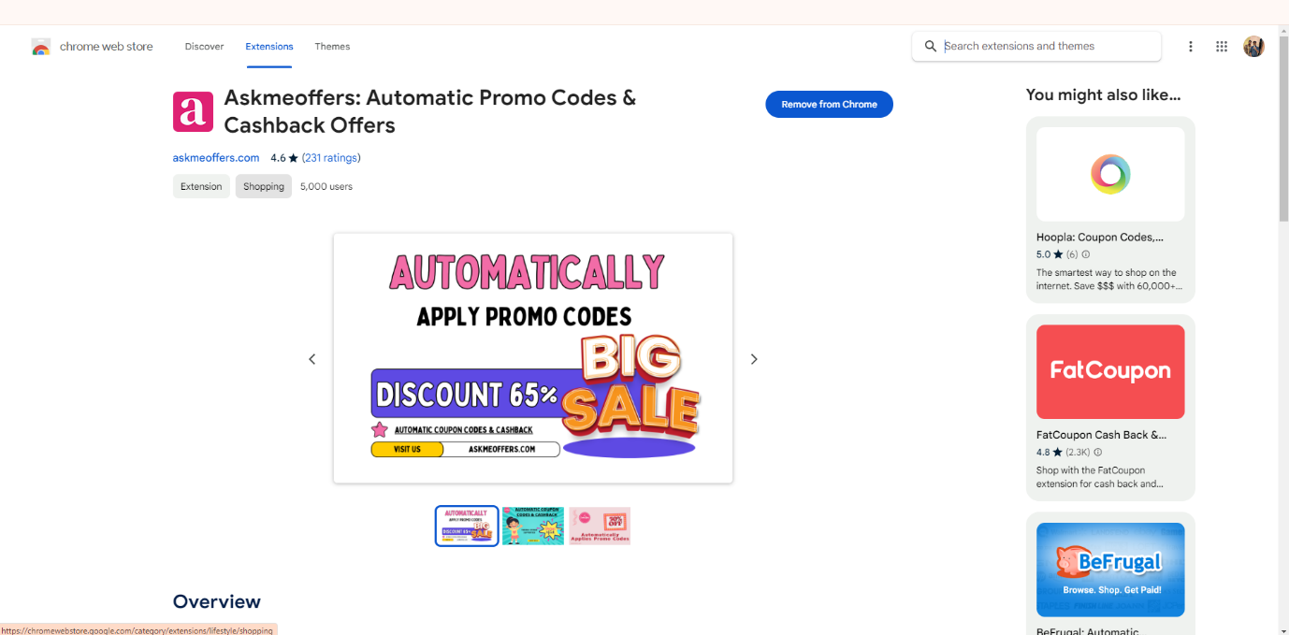The purpose of this report is to outline the results of the testing conducted on the AskMe Offers Automatic Coupons Chrome Extension. This testing aimed to evaluate the functionality, performance, and potential areas for improvement of the extension.

1. **Testing Cases**

The testing focused on the following aspects of the extension:

* Feature Enhancement
* Error Resolution
* Performance Optimization

1. **Testing Approach**

Our testing approach involved the following steps:

* Installation of the extension from the Chrome Web Store.
* Exploration of the extension's features and functionalities.
* Execution of test scenarios to identify any bugs or errors.
* Analysis of the extension's performance and potential areas for optimization.

1. **Testing Observation**

* Feature Enhancement:
* Identified potential improvements:
  + - Allow users to customize coupon application settings.
    - Expand the extension's compatibility with more online stores.
    - Integrate a feature to track savings over time.
    - Observe that the Interface of the extension is not user-friendly.

Remark –

1. The application lacks user-friendliness, making it challenging to locate required tokens amidst numerous articles on the homepage. Moreover, essential token details are inadequately presented, leading to a failure to provide customers with relevant information about the application's purpose.
2. 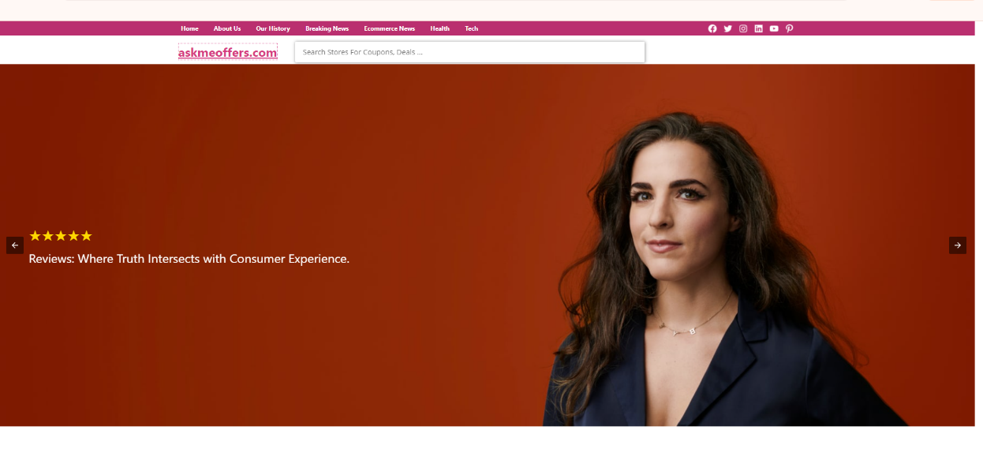The homepage banner occupies too much space, rendering it ineffective.
   * Error Resolution:
     + Encountered issues:
       - 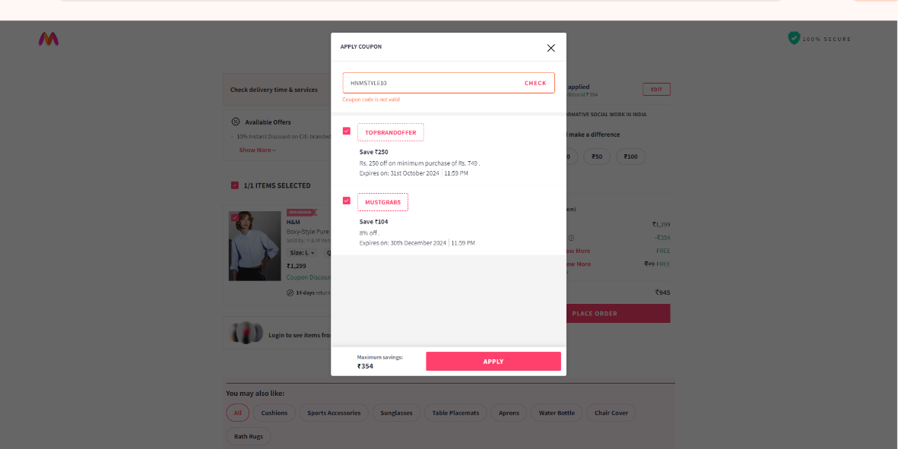Inconsistencies in coupon detection on certain websites.

* UI glitches during the coupon application process.

Remark-

1. Many tokens available for customers are invalid and require thorough verification before being made available for use.
2. The available tokens should include clear notes outlining their criteria and proper usage, facilitating easy and correct application by customers for their respective purposes
3. The application should categorize tokens based on different types of applications such as health, clothing, food, etc., to streamline access and organization for users.

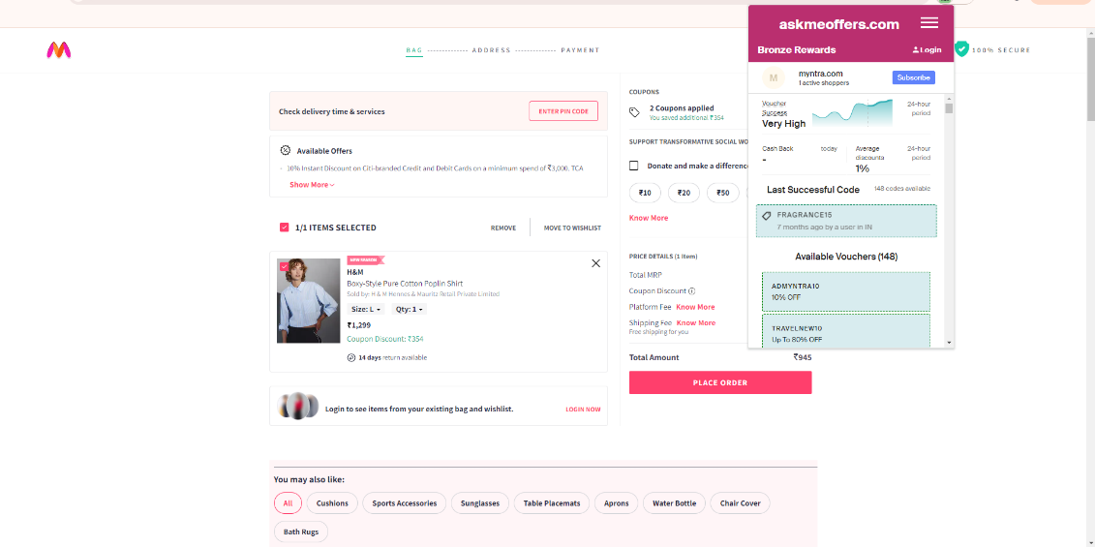

* Performance Optimization:
  + - Proposed enhancements:
* Optimize resource usage to prevent browser slowdown.
* Streamline coupon application process for faster performance.

1. **Conclusion**

Overall, the AskMeOffers Automatic Coupons Chrome Extension demonstrates promising functionality for enhancing online shopping experiences. However, there are areas for improvement identified through testing, including feature enhancements, error resolution, and performance optimization**.**

1. **Recommendations**

Based on the testing results, the following recommendations are provided for enhancing the extension:

* Prioritize fixing detected bugs and UI glitches.
* Implement user-requested features such as customizable settings and savings tracking.
* Optimize performance to ensure a smooth browsing experience and faster coupon application.

1. **Future Consideration**

Further testing and iteration should be conducted to address the identified issues and implement suggested enhancements. Continuous improvement efforts will contribute to the extension's effectiveness and user satisfaction.